2 August 2022

Creating greater opportunities in engineered wood

Henkel embarks on local production of Loctite PUR adhesives in Australia

Melbourne – Henkel, a global leader in the adhesives market, is slated to produce Loctite polyurethane (PUR) adhesives in Australia from the first half of 2023. The adhesives will be manufactured in Kilsyth, Victoria, to serve the engineered wood industry across Australia and New Zealand.

“Purbond adhesives are used globally and have long been the benchmark for innovation and reliability in the engineered wood industry. Producing Purbond locally is an exciting endeavor that opens many opportunities for us to help our customers in Australia and New Zealand to grow,” said Brad Simpson, Sales Manager and Business Unit Manager, Adhesives Technologies, Engineered Wood, Furniture and Building Components.

Henkel’s adhesive experts at its Innovation and Application Labs in Sydney and Auckland, help customers explore ways to expedite the time to market and optimize their own production processes for the development of engineered wood solutions. With the production of Purbond in Australia, adhesives production can be customized for specific performance requirements such as fire resistance and for use with modified timbers.

“By localizing the production of Purbond adhesives, our customers will benefit from reduced lead times from order to delivery, as well as greater supply chain security. This reflects our commitment to putting our customers at the center of what we do,” said Warren Grigsby, Business Development Specialist, New Zealand.

Purbond adhesives for engineered wood construction
With a growing environmental awareness surrounding construction and material use, engineered wood has become an increasingly popular design choice for load-bearing mass timber and high-tech structural engineering applications.

Approved for use in all major engineered wood construction markets, Loctite Purbond adhesives make it possible to manufacture glued wood components that are free from harmful industrial solvents and formaldehyde. In addition, they can be specifically engineered and controlled to enable the use of engineered wood in ever-new ways.

High resolution images can be downloaded here.

Image | English caption
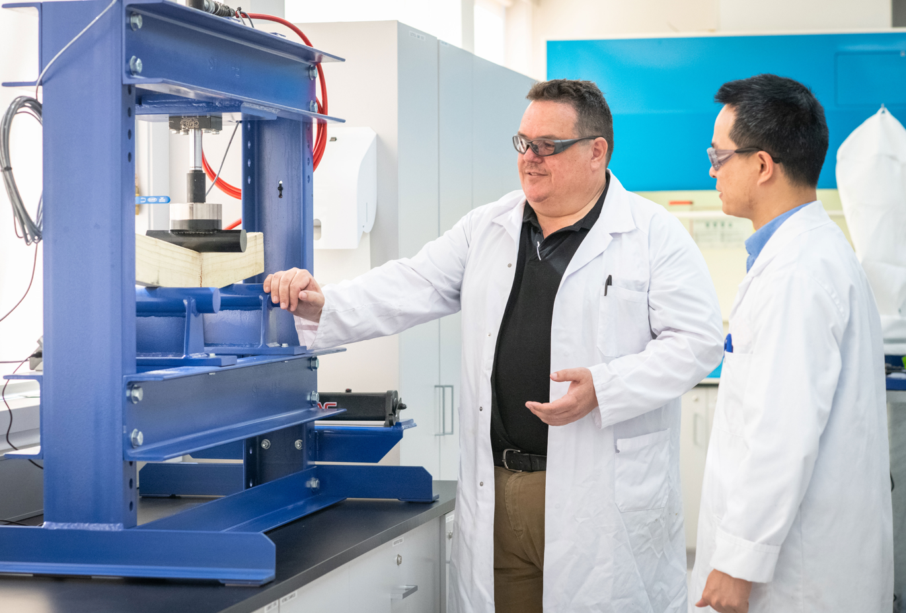 | Henkel’s adhesive experts help customers explore ways to expedite the time to market and optimize their own production processes for the development of engineered wood solutions.
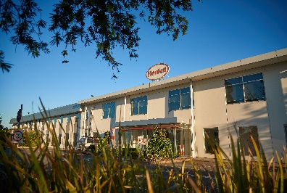 | From the first half of 2023, Henkel aims to produce Loctite polyurethane adhesives in its Kilsyth plant, to serve the engineered wood industry in Australia and New Zealand.
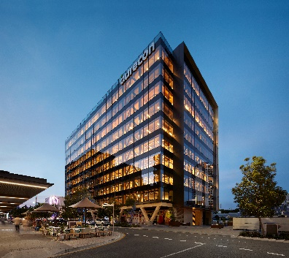 | Australia's highest wooden office building in King Street, Brisbane uses Loctite polyurethane adhesives to create high-performance load-bearing elements that combine with walls and ceilings of cross-laminated timber elements.
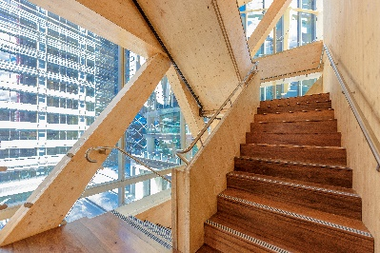 | Henkel's formaldehyde-free polyurethane adhesives were the first ones to meet the high standards for load-bearing wood construction. This has made it possible for the International House in Sydney to become one of the first multi-story office buildings in Australia to be built with wood.

About Henkel
Henkel operates globally with a well-balanced and diversified portfolio. The company holds leading positions with its three business units in both industrial and consumer businesses thanks to strong brands, innovations and technologies. Henkel Adhesive Technologies is the global leader in the adhesives market – across all industry segments worldwide. In its Laundry & Home Care and Beauty Care businesses, Henkel holds leading positions in many markets and categories around the world. Founded in 1876, Henkel looks back on more than 140 years of success. In 2021, Henkel reported sales of more than 20 billion euros and an adjusted operating profit of about 2.7 billion euros. The company employs more than 52,000 people globally – a passionate and highly diverse team, united by a strong company culture, a common purpose, and shared values. As a recognized leader in sustainability, Henkel holds top positions in many international indices and rankings. Henkel’s preferred shares are listed in the German stock index DAX. For more information, please visit www.henkel.com.

Photo material is available at www.henkel.com/press

Contacts  Hidemi Onoo  Henkel  Phone: +81 3-5783-1219  Email: hidemi.onoo@henkel.com | Liz Yip  Henkel  Phone: +65 9843 3346  Email: liz.yip@henkel.com

