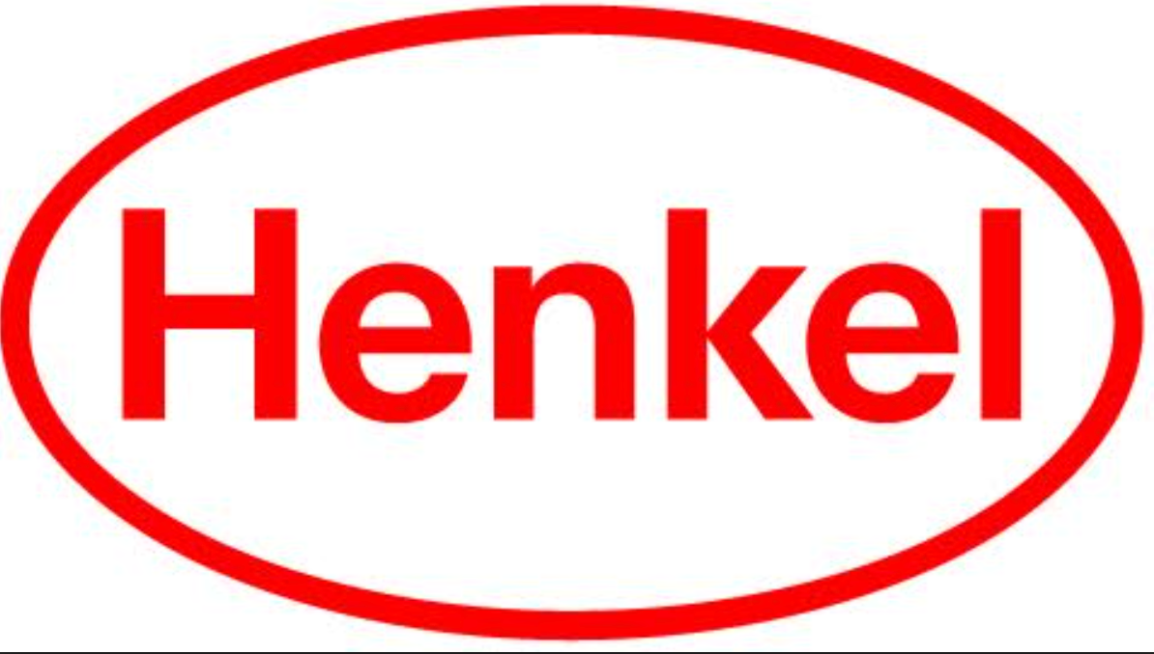

# Press Release

December 4, 2023

#1 Teacher recommended antibacterial hand soap*, Dial®, collaborates with DonorsChoose and TeacherLists to continue helping teachers and supporting healthy hygiene habits in schools.

**Dial® Gives Back to Teachers with DonorsChoose and TeacherLists This School Year**

Stamford, CT

Dial®, a trusted brand for 75 years, continues to acknowledge the pivotal role that teachers play in inspiring and shaping the future generation through its long-standing support of healthy handwashing education. As the #1 teacher recommended antibacterial hand soap*, giving back to its community has always been important to Dial, and this year the brand is building on their efforts from previous years by continuing to lend a helping hand to teachers.

A longtime goal and brand mission of Dial’s is to give educators the tools they need to teach the next generation and foster healthier communities by providing resources that support clean skin and proper hygiene practices. For the third consecutive year, Dial has partnered with [DonorsChoose](https://www.donorschoose.org), an education-focused nonprofit that allows individuals to support public schools. For Back-To-School season 2023, Dial made a $100,000 2x Match Offer donation to health and wellness projects at schools, which resulted in 947 funded projects, 639 schools served, and 772 teachers supported, 107 of whom had their first-ever project funded thanks to Dial’s partnership.

For the second year in a row, Dial strengthened the brand’s commitment to supporting teachers through a collaboration with TeacherLists, an organization that makes it easier than ever to create, share, and shop school supply lists. The platform serves the school community by connecting the world’s top brands with school districts, teachers, and parents to ensure that everyone can win back-to-school. In the 2023 Back-To-School season, Dial® Hand Soap appeared on over 15,000 school supply lists, reaching up to 360,000 students. For the last two years, Dial appeared as the “Most requested hand soap brand on TeacherLists”.

“At Dial, we will continue to support our teachers and give back to schools in a meaningful way that makes a tangible difference in the lives of so many,” says Nicole Vigue, Marketing Director at Henkel. “We are honored to be collaborating with DonorsChoose and TeacherLists again as we value their partnership and continuous efforts to help us foster healthy handwashing education in schools nationwide.”

Dial is proud to help support the wellbeing of teachers, students, and their classrooms with the help of DonorsChoose and TeacherLists. Teachers have the great responsibility of molding and shaping students for the future, and Dial wants to ensure that those who are educating the next generation on topics such as healthy hygiene habits have the tools that they need to succeed.

Learn more about Dial’s Give Teachers a Hand initiative and try Science of Clean lesson plans at [dialsoap.com/teachers](http://www.dialsoap.com/teachers).

*antibacterial liquid and foaming

**About Dial®**

America’s trusted brand for 75 years, Dial delivers body cleansing solutions for you and your family with products for Women, Men, and Kids. From bar soap, body wash, and hand soap, our products provide an individualized variety of benefits, including products that offer moisturization, exfoliation and antibacterial properties. Dial Up Your Day. www.dialsoap.com

**About Henkel in North America**

Henkel’s portfolio of well-known brands in North America includes Schwarzkopf® hair care, Dial® soaps, Persil®, Purex®, and all® laundry detergents, Snuggle® fabric softeners as well as Loctite®, Technomelt® and Bonderite® adhesives. With sales close to 6.5 billion US dollars (6 billion euros) in 2022, North America accounts for 27 percent of the company’s global sales. Henkel employs over 8,000 people across the U.S., Canada and Puerto Rico. For more information, please visit www.henkel-northamerica.com and on Twitter @Henkel_NA.

**About DonorsChoose**  
DonorsChoose is the leading way to give to public schools. Since 2000, 5.2 million people and partners have contributed $1.2 billion to support over 2 million teacher requests for classroom resources and experiences. As the most trusted crowdfunding platform for teachers, donors, and district administrators alike, DonorsChoose vets each request, ships the funded resources directly to the classroom, and provides thank yous and reporting to donors and school leaders. Charity Navigator and GuideStar have awarded DonorsChoose, a 501(c)3 nonprofit, their highest ratings for transparency and accountability. For more information, visit [www.donorschoose.org.](http://www.donorschoose.org.)

**About School Family Media**

As the back-to-school company, for 20-plus years After School Family Media (“ASFM”) has helped parents, teachers, and students kick off back-to-school and have a successful year. TeacherLists and PTO Today, ASFM’s nationally recognized platforms for school supplies and parent groups, sit at the center of the school community, connecting the world’s top brands with school districts, teachers, and parents to ensure that everyone can win back-to-school.

**Photo material is available at** [**www.henkel-northamerica.com/press**](http://www.henkel-northamerica.com/press)

## Dial Contact:

Carolanne Coviello**,** Creative Media Marketing Phone: 212-979-8884

Email: [carolanne@cmmpr.com](mailto:carolanne@cmmpr.com)

## Henkel North America Contact:

Erica Cooper

Phone: 475-232-4973

Email: erica.cooper@henkel.com