16 January 2024

**Henkel Opens New Asia R&D Center for Consumer Brands to Accelerate Growth and Product Innovation**

Shanghai — Henkel has officially opened its new Asia R&D Center for Consumer Brands in Shanghai with an investment of approximate 100 million RMB. As Henkel’s largest R&D facility in Asia, the new center will attract top scientific talent, bolster local R&D capabilities in both Hair and Laundry & Home Care, and further position Henkel consumer products at the forefront of the industry. It will contribute to agile product innovations based on local consumer habits and insights across 11 markets in Asia.

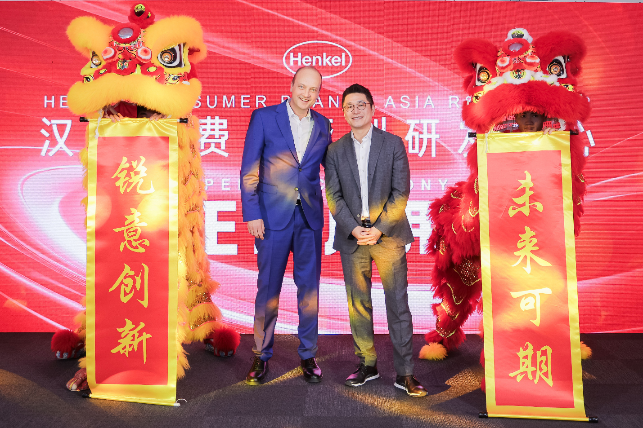

*Henkel opens new Asia R&D Center for Consumer Brands*

*From left: Frank Meyer, Corporate Senior Vice President R&D of Henkel Consumer Brands, David Tung, Regional President of Henkel Consumer Brands Asia*

**Frank Meyer, Corporate Senior Vice President R&D of Henkel Consumer Brands**, remarked, "Across our illustrious 140-year history, Henkel has consistently revolutionized consumer markets, positively impacting the lives of millions through our innovative products. The new R&D center, one of our facilities integrated with consumer centers worldwide, will contribute to a robust global research network spanning Europe, North America, the Middle East, and Asia Pacific. Anticipating the impact of this state-of-the-art facility, we aim to deepen our understanding of evolving consumer behaviors, fortifying Henkel's commitment to pioneering leading-edge technologies tailored for both local and global markets."

**David Tung, Regional President of Henkel Consumer Brands Asia**, said, “This investment represents a pivotal milestone as the first Asia-based R&D center supporting product development and ingredient formulation for both business categories. Leveraging unique research synergies, the center is set to shape our portfolio for higher growth, adding substantial value to the Asian market and propelling Henkel Consumer Brands to new heights.”

Occupying over 2,500 square meters of floor space, the new R&D center offers ample capacities for future growth ambitions and expanded capabilities. Built on the design concept of 'innovation, digitalization, and sustainability,' the R&D center features advanced equipment and encompasses comprehensive capabilities, catering to both current and future needs of Henkel Consumer Brands. It integrates six functional areas: consumer center, advance research, product development, packaging design, chemical and physical analysis, and product evaluation.

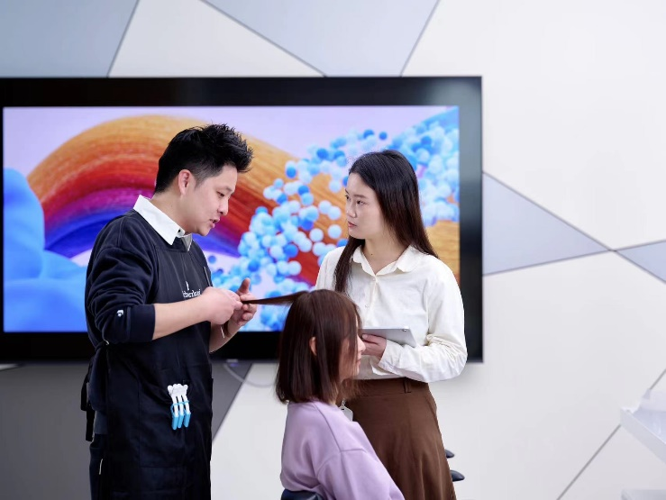

*Professional hairdressers diagnose hair condition for consumer.*

* The **consumer center** is designed to mirror the hair salons and the home environments that consumers are familiar with, enabling Henkel to engage more profoundly with them and transform insights into innovation processes.
* The center will pioneer **advanced research** and explore breakthrough technologies, using in-vitro and in-vivo testing for comprehensive validation.
* The center will support **formula development** and product format development based on consumer and customer needs, ensuring the safety, stability, sensory performance and efficacy of products.
* Advanced instruments and 3D printing technologies will empower **packaging design** by enabling Henkel to conduct fast prototyping and validate the performance of packaging during its shelf life.
* In the **chemical and physical analysis lab,** Henkel experts can conduct both qualitative and quantitative analyses on active components, impurities, and other factors, to develop comprehensive insights into raw materials and product performance and quality.
* **Performance evaluations** are empowered by advanced biophysical test instruments and alaundry performance evaluation lab that can provide accurate and relevant technical performance assessment and validation of laundry products.

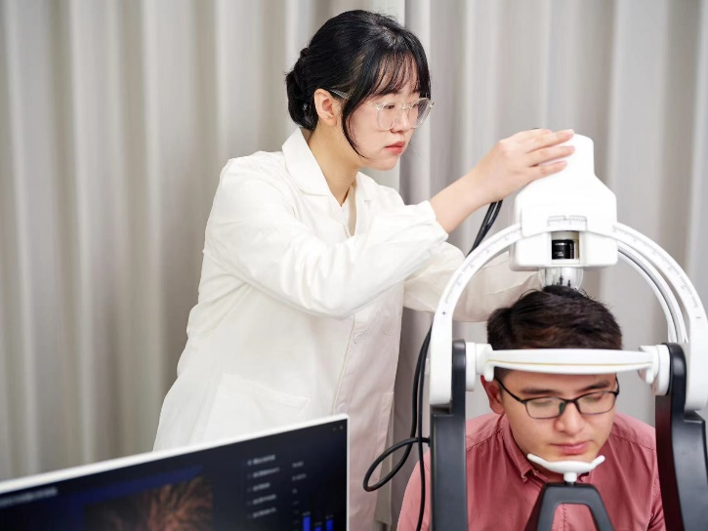

*Henkel expert utilizes scalp positioning and capturing system to detect scalp health condition for consumer.*

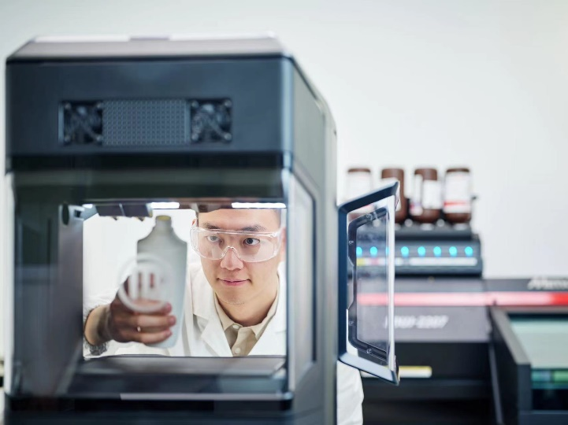

*Henkel expert leverages 3D printers for rapid prototyping and iteration of product packaging, accelerating the development of innovative projects.*

**Rajat Agarwal, President of Henkel Greater China** emphasized, “China is one of Henkel’s key strategic markets and plays a critical role in our regional and global business. We are continuously building our local R&D capabilities to respond to the distinctive consumer trends taking place in this dynamic market. This investment further underscores our commitment to the local market, empowering us to develop customized solutions for consumers and pioneer sustainability in China and across the region.”

About Henkel

With its brands, innovations and technologies, Henkel holds leading market positions worldwide in the industrial and consumer businesses. The Adhesive Technologies business unit is the global leader in the market for adhesives, sealants and functional coatings. With Consumer Brands, the company holds leading positions especially in hair care and laundry & home care in many markets and categories around the world. The company's three strongest brands are Loctite, Persil and Schwarzkopf. In fiscal 2022, Henkel reported sales of more than 22 billion euros and adjusted operating profit of around 2.3 billion euros. Henkel’s preferred shares are listed in the German stock index DAX. Sustainability has a long tradition at Henkel, and the company has a clear sustainability strategy with specific targets. Henkel was founded in 1876 and today employs a diverse team of about 50,000 people worldwide – united by a strong corporate culture, shared values and a common purpose: "Pioneers at heart for the good of generations.” More information at [www.henkel.com](http://www.henkel.com)

Materi foto tersedia di [**www.henkel.com/press**](http://www.henkel.com/press)

**Kontak media**

Meiling Wee

+65 8799 3216

[meiling.wee@henkel.com](mailto:meiling.wee@henkel.com)