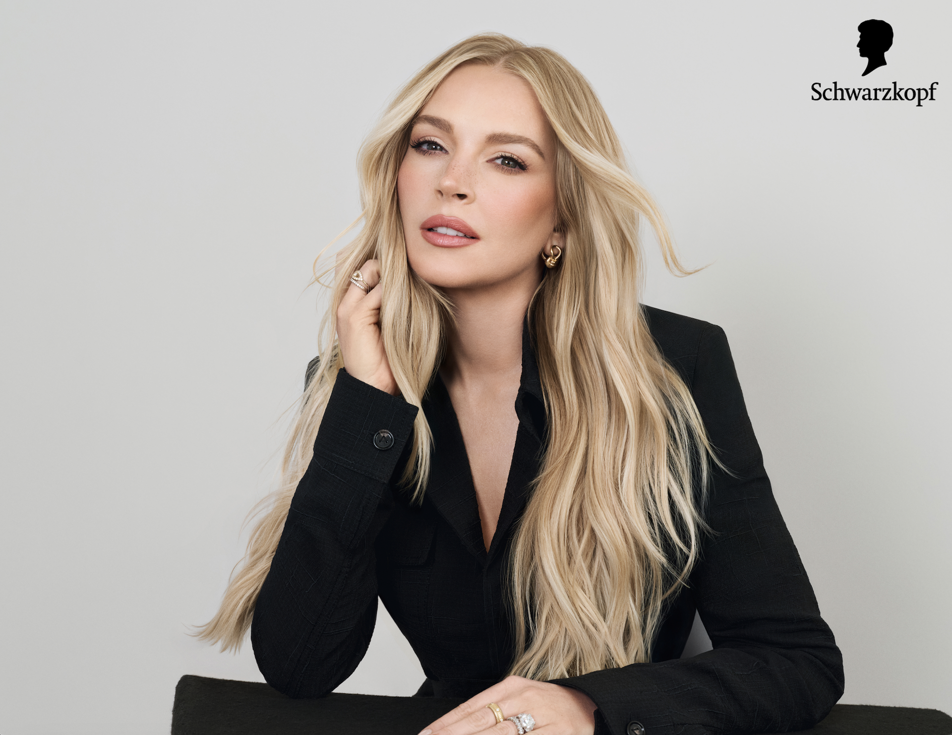

**Schwarzkopf Unveils Lindsay Lohan as Newest Brand Ambassador**

*Partnership celebrates Schwarzkopf’s world-class hair color formulas, trust & the longstanding bond between client and colorist*

**[Los Angeles, CA] — [July 8, 2025]** — Schwarzkopf, an authority in hair for over 125 years, is proud to announce Lindsay Lohan as its newest Brand Ambassador. This partnership celebrates Lohan’s longstanding relationship with Schwarzkopf Professional’s very own Tracey Cunningham, the iconic celebrity colorist who has been coloring her hair for over two decades.

*"Tracey is more than my colorist—she’s a trusted creative partner,"* said Lohan*. “Whether I’m in a new movie or walking a red carpet - there’s only one shot to get my hair color right and it’s often a really tight turnaround. Tracey is the ultimate collaborator, and I love that she takes the time to explain what products she uses and why. I learned about Schwarzkopf through Tracey because the result is so incredible every time and it’s now the only brand I trust in the salon."*

Lohan has never been afraid to change up her hair color. The blonde she debuted this past March made waves as a covetable shade highly requested by salon goers. This latest look is a new variation of blonde named “Soft Gloss Blonde” by Cunningham - a bright, vibrant shade perfect for summer nights and reminiscent of Hollywood starlets as Lohan gears up for the highly anticipated *Freakier Friday*. For the first time Schwarzkopf and Cunningham are sharing the exact formula behind Lohan’s blonde.

*“We love the fun that Lindsay has with her hair color. Her looks reflect the personal connections that people have with their hair and the trust they place in the professionals and brands who turn their visions into realities throughout each chapter of their lives,”* said Teresa Cordova, Head of Schwarzkopf Masterbrand U.S*. “At Schwarzkopf, we’re proud to create the high-performance color formulas that fuel those moments of change.*”

For Cunningham, Schwarzkopf Professional’s U.S. Creative Director of Color & Technique, working with high performance, high quality hair color formulas is key.

*"Lindsay and I have grown together over the years, and it’s always the most fun having her in my chair,"* said Cunningham. *"To take her lighter, Schwarzkopf Professional’s IGORA VIBRANCE and BLONDME were absolute essentials. These formulas allowed me to lift her hair color while maintaining its integrity and shine. It’s imperative that I trust the products I’m using on all my clients. There is zero room for error when working with an A-List celebrity or musician undergoing a color transformation for a film or TV role, a red carpet or a musical performance. I know that I can always count on Schwarzkopf Professional products to deliver.”*

Sold in over 140 countries worldwide, Schwarzkopf Professional is a brand that colorists like Cunningham can trust. Schwarzkopf Professional formulas are world-class thanks to decades of research and innovation. Schwarzkopf’s BLONDME lightener, with bonding technology that helps minimize hair damage when used with BLONDME Premium Developer, helped Tracey achieve Lohan’s signature “Soft Gloss Blonde”. She then used Schwarzkopf’s signature demi-permanent color line, IGORA Vibrance to give Lohan’s hair shine. IGORA Vibrance not only provides highly customizable color and lasts up to 25 washes, but can also be used as a gloss to provide vibrant shine.

To support its professional community, Schwarzkopf Professional is unveiling a limited-time endcap at professional beauty distributors nationwide, spotlighting the exact products and hair color formulas Tracey used to create Lohan’s look. Designed with colorists in mind, the activation underscores Schwarzkopf’s commitment to education, performance, and community.

Outside of the salon - for those who are inspired by Lohan’s standout blonde look, Schwarzkopf’s Keratin Blonde shade “[11.0 Hi-Lift Natural Blonde” is a](https://www.schwarzkopf.com/brands/haircolor/keratin-color/keratin-blonde/11-0-natural-blonde.html) premium DIY solution. Keratin’s at-home color products offer 100% grey coverage and feature Keratin’s Bond Enforcing System, for up to 80% less breakage vs. untreated hair.

Lohan’s approach to hair color is the perfect expression of confidence and creativity. It’s the philosophy Schwarzkopf stands behind. Great color doesn’t just transform your hair—it transforms your story. **What story will you tell?**

Ask for Schwarzkopf color at your next salon appointment and visit [Schwarzkopf Professional](https://www.schwarzkopf-professional.com/us/en.html) to explore the products. Follow @hairbyschwarzkopf.usa and @schwarzkopfusa on Instagram and TikTok to discover the latest color trends and re-create your favorite color looks.

**About Henkel in North America**

Henkel’s portfolio of well-known brands in North America includes all®, Purex® and Persil® laundry detergents, Snuggle® fabric softeners, Dial® soaps, Schwarzkopf® hair care, as well as Loctite®, Technomelt® and Bonderite® adhesives. With sales close to 6.5 billion US dollars (6 billion euros) in 2024, North America accounts for 28 percent of the company’s global sales. Henkel employs around 8,000 people across the U.S., Canada and Puerto Rico. For more information, please visit [www.henkel-northamerica.com](http://www.henkel-northamerica.com) and on X [@Henkel_NA](https://twitter.com/Henkel_NA).