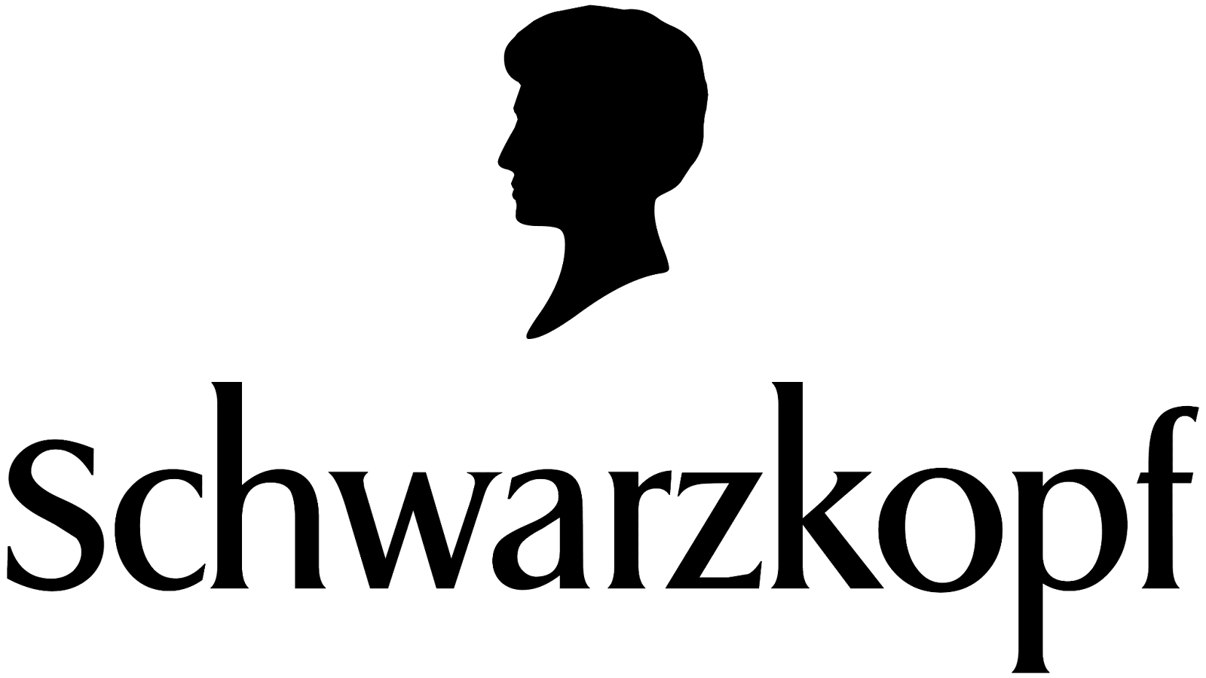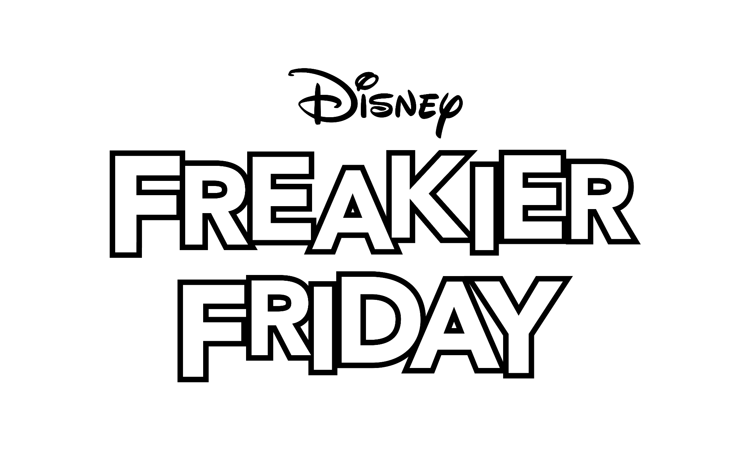

**Schwarzkopf Celebrates Bold Transformation with Disney’s *Freakier Friday****The “Switch Your Story” campaign is Schwarzkopf’s first-ever collaboration with The Walt Disney Studios*

**LOS ANGELES, CA — [July 22, 2025]** — Schwarzkopf, an authority in hair for over 125 years, is proud to be the official Hair Brand of Disney’s *Freakier Friday,* only in theaters August 8th. To celebrate the collaboration, Schwarzkopf will spotlight the power of transformation with a multi-platform “Switch Your Story” campaign highlighting the special role hair color plays in telling consumer stories. Inspired by the film’s iconic theme of switching places and embracing change, the campaign invites consumers and professionals alike to explore how hair color and making the switch to Schwarzkopf hair color products can spark confidence, creativity, and self-expression. The campaign will run across paid media channels including connected TV and social platforms, with messaging tailored to both salon professionals and at-home users.

“*Freakier Friday* reminds us how powerful it can be to switch things up, and at Schwarzkopf, we believe that every hair color change marks the start of a new chapter in your story,”said Teresa Cordova, Head of Schwarzkopf Masterbrand U.S.“As a brand trusted by both salon professionals and at-home users, we're proud to create high-performance formulas that help people express who they are today and who they are becoming.”

In addition to its digital rollout, Schwarzkopf’s “Hairstream”, a beautifully branded mobile hair salon, will be on-site at the film’s Los Angeles premiere, offering professional hair styling services including hair tinsel & hair charm applications. Premiere attendees will also be able to “switch their story” instantly using the mobile salon’s “Magic Mirror” - an augmented reality mirror that allows users to visualize what they would look like with different hair colors. To continue the celebration, the Hairstream will also pop up in Los Angeles at Manhattan Village for a weekend consumer activation on Saturday, July 26 and Sunday, July 27 from 10am to 6pm. Fans can enjoy the same VIP Schwarzkopf styling experience offered at the premiere and share their hair stories.

The campaign celebrates Schwarzkopf’s world-class professional and at-home color products that are sold in over 140 countries. The brand will share professional salon formulas and at-home box dye shade suggestions inspired by the film’s bold hair color looks - providing consumers with options for recreating similar shades in the salon or at home. For professional colorists looking to recreate the film’s looks for their clients – Schwarzkopf is encouraging colorists to make the switch to its beloved **IGORA Vibrance**, a state-of-the-art demi-permanent hair color with multi-tonal color results and beautiful vibrant shine – a go-to for advanced color services including toning, glossing, root smudging, and grey blending. For consumers looking to recreate the film’s looks from home, Schwarzkopf’s **Keratin Color** box dye**,** which offers 100% gray coverage and up to 80% less breakage (vs. untreated hair) thanks to Keratin Color’s Bond Enforcing technology, will take center stage.

As Schwarzkopf celebrates the power to “Switch Your Story”- what story will you tell?

Ask for [Schwarzkopf color](https://www.schwarzkopf-professional.com/us/en.html) at your next salon appointment or visit [Keratin Colo](https://www.schwarzkopf.com/brands/haircolor/keratin-color.html)r to learn how to switch your hair story at home. Salon professionals looking to make the switch to Schwarzkopf can learn more [here](https://www.schwarzkopf-professional.com/us/en/you-and-us/switch-with-tracey.html). Follow [@hairbyschwarzkopf.usa](https://www.instagram.com/hairbyschwarzkopf.usa/?hl=en) and [@schwarzkopfusa](https://www.instagram.com/schwarzkopfusa/?hl=en) on Instagram and TikTok to discover the latest color trends and re-create your favorite color looks.

**About Henkel in North America**

Henkel’s portfolio of well-known brands in North America includes all®, Purex® and Persil® laundry detergents, Snuggle® fabric softeners, Dial® soaps, Schwarzkopf® hair care, as well as Loctite®, Technomelt® and Bonderite® adhesives. With sales close to 6.5 billion US dollars (6 billion euros) in 2024, North America accounts for 28 percent of the company’s global sales. Henkel employs around 8,000 people across the U.S., Canada and Puerto Rico. For more information, please visit [www.henkel-northamerica.com](http://www.henkel-northamerica.com) and on X [@Henkel_NA](https://twitter.com/Henkel_NA).

**About Disney’s *Freakier Friday***

“Freakier Friday,” the eagerly anticipated sequel to the Disney classic starring Jamie Lee Curtis and Lindsay Lohan, will be released in theaters nationwide August 8, 2025. In the film, Curtis and Lohan reprise their roles as Tess and Anna Coleman. The story picks up years after Tess (Curtis) and Anna (Lohan) endured an identity crisis. Anna now has a daughter of her own and a soon-to-be stepdaughter. As they navigate the myriad challenges that come when two families merge, Tess and Anna discover that lightning might indeed strike twice. “Freakier Friday” is directed by Nisha Ganatra, and the screenplay is by Jordan Weiss, with a story by Elyse Hollander and Jordan Weiss, based on the book “Freaky Friday” by Mary Rodgers. The film, which also stars Julia Butters, Sophia Hammons, Manny Jacinto, Maitreyi Ramakrishnan, Rosalind Chao, Chad Michael Murray, and Mark Harmon, is produced by Kristin Burr, p.g.a., Andrew Gunn, p.g.a., and Jamie Lee Curtis, with Ann Marie Sanderlin, Mario Iscovich, Nathan Kelly, and Lindsay Lohan serving as executive producers. Rated **[PG] for thematic elements, rude humor, language and some suggestive references**