February 04, 2026

Joint venture to leverage synergies and to accelerate growth of high-performance building products and facade systems

Henkel and Wetherby Laroc enter a strategic partnership

Düsseldorf, Germany & Dalton, United Kingdom – Henkel, a global leader for adhesives, sealants and coatings, and Wetherby Laroc, a UK-based manufacturer of high-performance building products and facade systems, today have announced to enter a strategic partnership in form of a joint venture. As part of this partnership, Henkel has signed an agreement to become majority shareholder of Wetherby Laroc. The joint venture will enable both companies to grow their core businesses by combining Wetherby Laroc’s strong local brands and market presence with Henkel’s global innovation and technology capabilities.

The European market for facade solutions is highly attractive due to a strong demand for energy-efficient buildings, modernization of ageing housing stock, and increasingly strict sustainability regulations that require high-performance exterior systems. Within this landscape, the UK stands out as a particularly compelling growth opportunity, driven by its large renovation market, and ongoing investment in residential and commercial construction. The partnership with Wetherby Laroc will enable Henkel to serve the local market by offering customers a broader portfolio of premium, certified facade solutions, while establishing a solid joint foundation for expansion across Europe.

“We are delighted to enter a joint venture partnership with Wetherby Laroc which will enable us to create a sustainable future with builders through unmatched expertise, superior quality, and leading innovation”, explained Piotr Ciborowski, Vice President Construction Eastern Europe at Henkel Adhesive Technologies. “Our combined solution portfolio and expertise address critical business challenges and empower customers to transform legacy housing stock into energy-efficient buildings contributing to significant sustainability improvements and cost-saving potentials. Based on our joint distribution network and trusted brands we aim to accelerate market innovation with focus on the UK and laying the foundation to meet future needs of our European customers as well.”
“My vision for the future has always been clear, to be market-leading in every aspect of our business and operations, while building a culture driven by continuous improvement and sustainable growth,” said Alex Chalmers, Managing Director at Wetherby Laroc. “I am very proud and excited to be entering into this joint venture partnership which brings together two-family businesses with complementary strengths and a shared ambition for growth and innovation, while delivering long-term value to our customers. By combining the expertise, resources, and capabilities of both organisations, we are creating a stronger and more resilient business with enhanced innovation and technology. This partnership will create strategic synergies for accelerated growth by expanding our products, systems and categories enabling us to deliver a broader and more compelling product and system offering for customers and supports our continued investment in future growth.”

The transaction is closed and completed, and the companies agreed not to disclose financial details of the transaction.

About Henkel
With its brands, innovations and technologies, Henkel holds leading market positions worldwide in the industrial and consumer businesses. The business unit Adhesive Technologies is the global leader in the market for adhesives, sealants and coatings. With Consumer Brands, the company holds leading positions especially in laundry & home care and hair in many markets and categories around the world. The company's three strongest brands are Loctite, Persil and Schwarzkopf. In fiscal 2024, Henkel reported sales of more than 21.6 billion euros and adjusted operating profit of around 3.1 billion euros. Henkel’s preferred shares are listed in the German stock index DAX. Sustainability has a long tradition at Henkel, and the company has a clear sustainability strategy with specific targets. Henkel was founded in 1876 and today employs a diverse team of about 47,000 people worldwide – united by a strong corporate culture, shared values and a common purpose: "Pioneers at heart for the good of generations.” More information at www.henkel.com

About Wetherby Laroc
Wetherby Laroc is a UK-based, innovation- and technology-led manufacturer of high-performance building products and facade systems. Established in 1977 and operating across multiple established brands, the business supports contractors, architects, specifiers, and distribution partners with technically robust systems formulated for ease of use and long-term proven performance. With manufacturing and operational facilities in North Yorkshire, Wetherby Laroc combines technical expertise, product innovation, and service-led support to meet the evolving demands of the construction industry. Committed to responsible manufacturing, continuous improvement, and investing in people, processes, and products that support sustainable growth. For more information, visit www.wetherbygroup.com.

Photo material is available at www.henkel.com/press

Contact Sebastian Hinz
Phone +49 211 797 – 85 94
Email sebastian.hinz@henkel.com

Henkel AG & Co. KGaA

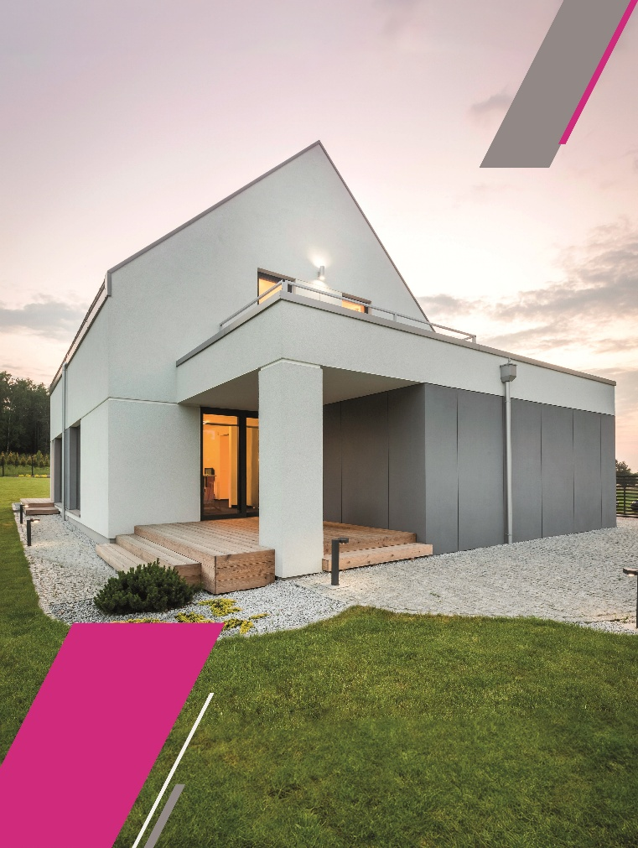

Henkel has entered a strategic partnership with Wetherby Laroc, a UK-based manufacturer of high-performance building products and facade systems (Image: Wetherby Laroc).

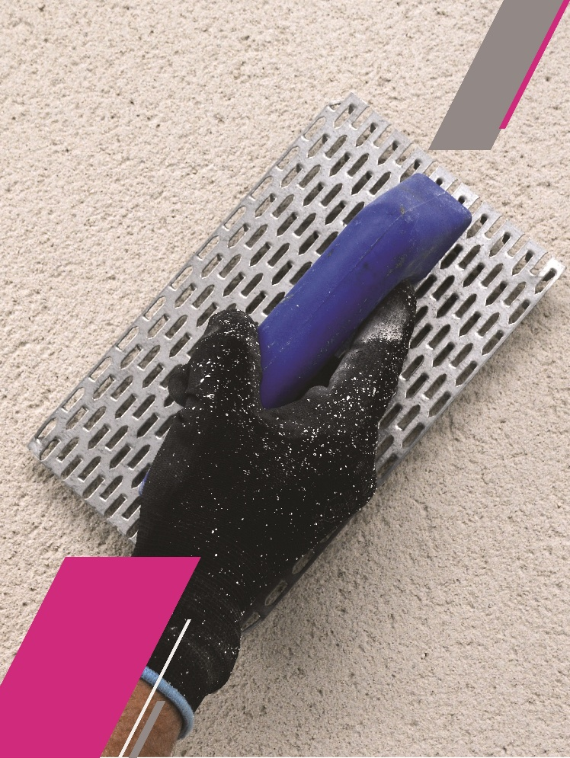

The partnership with Wetherby Laroc will enable Henkel to offer customers a broader portfolio of premium, certified facade solutions (Image: Wetherby Laroc).

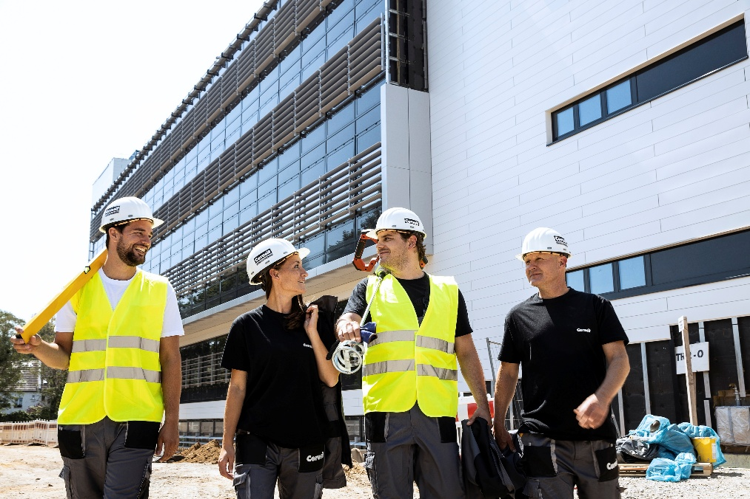

Henkel is a global leader for adhesives, sealants and coatings providing a wide range of solutions for the construction industry under well-known brands such as Ceresit.

