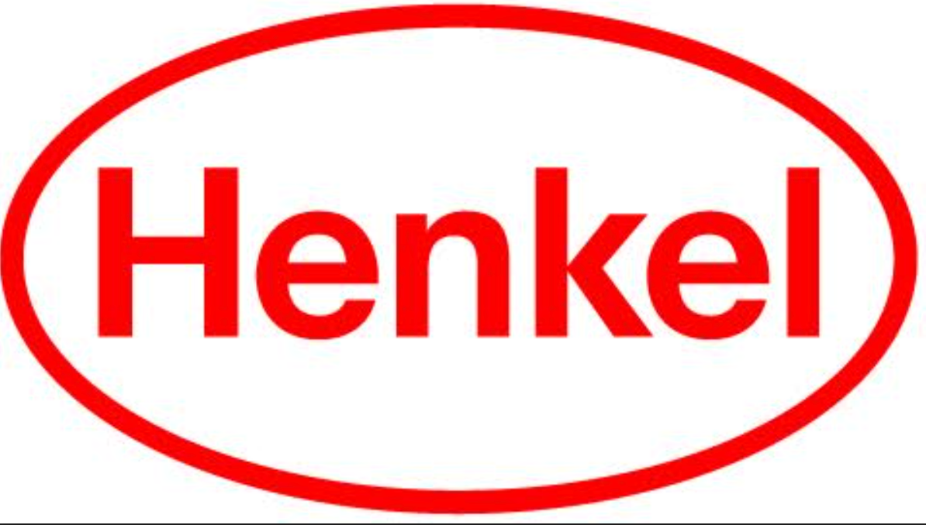
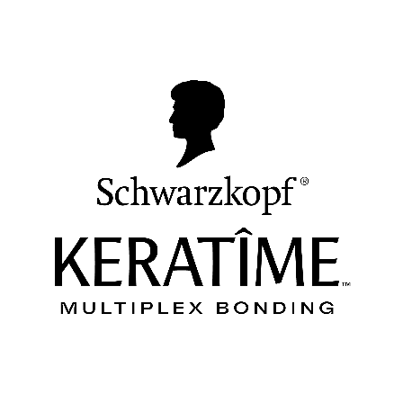

Press Release
March 5, 2026

Backed by Country Music Star and Entrepreneur Jessie James Decker and Celebrity Hairstylist Kylee Heath, the new KERATÎME™ Care & Styling collection marks the next chapter of the Schwarzkopf® brand expansion in the US.

Schwarzkopf® Brand Expands its Legacy of Hair Innovation with the Launch of KERATÎME™ Care & Styling

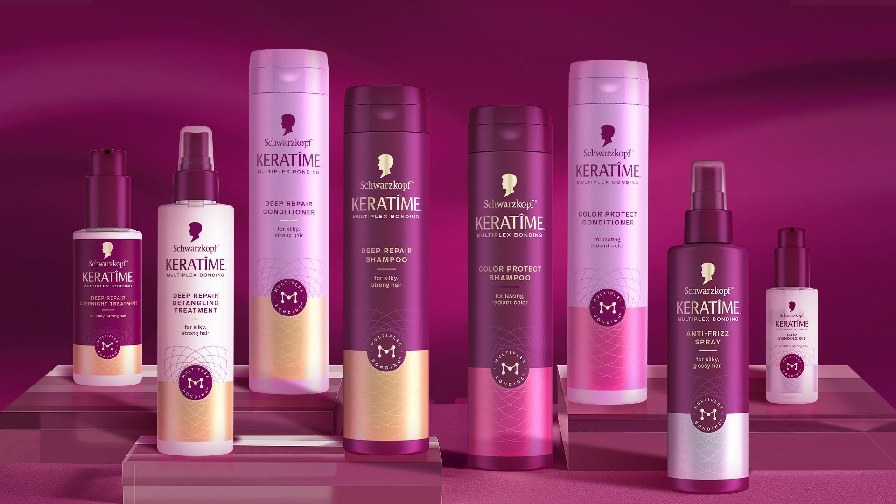

Stamford, CT

Schwarzkopf, the authority in hair with over 125 years of global hair and professional expertise, is bringing its heritage to Walmart with the launch of KERATÎME Care & Styling. Exclusively available at Walmart, the new line is powered by the brand’s proprietary Multiplex Bonding Technology™, offering professional-quality care for consumers at home. Schwarzkopf is on a mission to expose the secret to amazing hair and this launch marks a major evolution for the brand - expanding its leadership from its innovative at-home hair color solutions into the rapidly growing hair bonding category.

Schwarzkopf’s expertise in bonding technology began with its Schwarzkopf Keratin Color portfolio, which introduced K-Bond Plex® conditioner, a multi-step bond-enforcing system designed to create bonds, reduce hair breakage* and deliver rich, long-lasting color with up to 100% gray coverage. That innovation reinforced Schwarzkopf’s longstanding commitment to both color performance and hair bonding technology, underscoring a distinct dual benefit that pairs vibrant, long-lasting color with bond-enforcing care. With KERATÎME Care & Styling, Schwarzkopf builds on that foundation of dual benefits and introduces a new frontier in bond building, while providing additional, relevant care & styling benefits at the same time. Based on KERATÎME’s next-generation Multiplex Bonding Technology, this advanced system builds bonds within the hair fiber and protects from future damage with every use**, protects color vibrancy, or provides powerful styling effects, addressing the cumulative effects of washing, heat styling, coloring and environmental stress. The result is a comprehensive hair routine that strengthens, protects and styles in one.

“Over the last 125+ years, Schwarzkopf has continuously pioneered innovations that help consumers express themselves with confidence,” said Linda Lin, Head of Consumer Hair at Henkel. “With the launch of KERATÎME, we are on a mission to expand that legacy into care and styling in an exciting new way, and we’re thrilled to partner exclusively with Walmart to bring this next chapter of hair health innovation to consumers nationwide.”

To bring this innovation to life, the Schwarzkopf brand has partnered with Country Music Star, Entrepreneur and Schwarzkopf Brand Ambassador Jessie James Decker and Celebrity Hairstylist and Schwarzkopf Brand Ambassador Kylee Heath as the official faces of KERATÎME. Heath, recognized for her work with A-list talent and editorial campaigns, brings professional authority and technical insight while Decker embodies real-life transformation and everyday beauty routines that resonate with consumers.

“Jessie and Kylee represent the dual spirit of Schwarzkopf- expert craftsmanship and authentic, lived-in beauty,” added Linda Lin, Head of Consumer Hair at Henkel. “Their voices and perspectives help tell the full story of why KERATÎME matters to consumers and stylists alike.”

When speaking about the partnership, Jessie James Decker said:
“Hair has always been a big part of how I express myself - whether I’m on stage or just living life with my family. I’m so excited to partner with Schwarzkopf because they make real, everyday hair care and color feel accessible and transformative. It’s about empowering people to love their hair and feel their best, no matter what their routine looks like.”
Why this partnership was a perfect fit for celebrity stylist Kylee Heath:
“I’ve always believed that healthy hair is the foundation of every great look. That’s what drew me to partner with Schwarzkopf - they have 125+ years of history and continue to innovate. The new KERATÎME Care & Styling collection was built on real science that strengthens hair from the inside out**. I’m excited about connecting with consumers and sharing the education behind each of the products. I love helping people feel confident in their hair, and this collection gives everyone the tools to do that.”
The launch of KERATÎME Care & Styling marks a strategic partnership with Walmart, bringing Schwarzkopf’s latest innovation directly to millions of beauty shoppers nationwide through an exclusive retail debut on March 5, 2026. As part of the launch, KERATÎME will activate at the Walmart Spring Beauty Event Pop-Up in Plano, TX from March 5 through April 6 on Thursday-Monday of each week. The pop-up serves to introduce consumers to the new collection through immersive in-store experiences, product education and discovery moments. This exclusive rollout underscores Schwarzkopf’s commitment to making professional-quality care and styling accessible at mass retail. To celebrate the launch, both Jessie James Decker and Kylee Heath will be making a special appearance at the pop-up on Saturday, March 21. Consumers are invited to stop by to get a first look at the products, receive hair consultations and exclusive meet & greet opportunities.
Designed to work seamlessly across hair care routines, the KERATÎME Care & Styling range consists of 3 sublines: Deep Repair, Color Protect and Styling; all in premium formulations with accessible mass-prestige positioning at $14.97***. The product assortment includes:
- Deep Repair Shampoo
  - Formulated for dry, damaged hair, this shampoo gently cleanses with a rich, creamy lather and is infused with keratin and silk extract. It delivers care while protecting against future damage**. Designed with Multiplex Bonding Technology, this shampoo builds bonds within the hair fiber**.
- Deep Repair Conditioner
  - Elevate your hair care routine with KERATÎME Deep Repair Conditioner, designed to do more than just soften—it strengthens and protects*, while leaving hair feeling silky-soft and smooth. Thoughtfully formulated with our next-generation bonding technology, this conditioner is ideal for dry, damaged hair and leaves hair feeling healthy after just 1 use.
- Deep Repair Overnight Treatment
  - Designed to repair even very damaged hair, Schwarzkopf KERATÎME Deep Repair Overnight Treatment works while you sleep, strengthening* hair for that silky-smooth hair feel you love. Our unique solution for silky-smooth and strong** hair is powered by Multiplex Bonding Technology.
- Deep Repair Detangling Treatment
  - Strengthen* damaged hair with our leave-in Deep Repair Detangling Treatment, featuring Multiplex Bonding Technology. Transform fragile, damage-prone hair into strong, resilient hair with our breakthrough formula. This advanced spray treatment gives you extra care in seconds.
- Color Protect Shampoo
  - Designed for color-treated hair, this shampoo helps lock in brilliance while gently cleansing in a rich, creamy lather. With the power of our unique Multiplex Bonding Technology, it strengthens your hair from the inside out** while protecting the color vibrancy you love.
- Color Protect Conditioner
  - Schwarzkopf KERATÎME Color Protect Conditioner is expertly crafted to give 4x stronger** hair while protecting color vibrancy, powered by Multiplex Bonding Technology. Designed for color-treated hair, it helps lock in brilliance while detangling, maintains smoothness, and lavishly conditions. The result: radiant, healthy-looking hair with up to 12 weeks of color vibrancy****.
- Hair Bonding Oil
  - Schwarzkopf KERATÎME Hair Bonding Oil combines style and care for smooth, 10x stronger* hair, and enhanced shine with every use. This lightweight, fast-absorbing formula provides up to 450°F heat protection, making it suitable for use with blow dryers, straighteners, or curling irons. The formula features silk extract, and it helps smooth the hair’s surface to instantly enhance shine and deliver a reflective, high-gloss finish.
- Anti-Frizz Spray
  - Schwarzkopf KERATÎME Anti-Frizz Spray is expertly crafted to help smooth frizzy texture for hair that is easy to manage. Anti-Frizz Spray, containing Multiplex Bonding Technology, strengthens and builds bonds inside your hair*, while also sealing and protecting the outside of your hair. It enhances shine and leaves hair beautifully smooth.

The KERATÎME launch campaign will roll out across national media, digital platforms and social content with exclusive perspectives from both talent partners. Interviews and first-look visuals with Kylee Heath and Jessie James Decker are available for media, alongside product imagery and expert commentary from Schwarzkopf R&D.
Evolution has been constant as the Schwarzkopf brand has grown over the last century and they will continue to keep innovating and elevating its hair care products and formulas. For more information, visit Schwarzkopf.com and follow @hairbySchwarzkopf.usa on Instagram, @hairbyschwarzkopf.usa on TikTok and @hairbyschwarzkopfusa on YouTube for updates.

About Henkel in North America:
Henkel’s portfolio of well-known brands in North America includes all®, Purex® and Persil® laundry detergents, Snuggle® fabric softeners, Dial® soaps, Schwarzkopf® hair care, as well as Loctite®, Technomelt® and Bonderite® adhesives. With sales close to 6.5 billion US dollars (6 billion euros) in 2024, North America accounts for 28 percent of the company’s global sales. Henkel employs around 8,000 people across the U.S., Canada and Puerto Rico. For more information, please visit www.henkel-northamerica.com and on X @Henkel_NA.

Schwarzkopf® US PR Contact:
Carolanne Coviello, Creative Media Marketing Phone: 212-979-8884
Email: carolanne@cmmpr.com

*against combing breakage vs. untreated damaged hair
**when used as a system against combing breakage vs untreated
***pricing is at the sole discretion of the retailer
****through 40 washes

