LOCTITE® 3921™ Light Cure Acrylic Adhesive Offers Faster Processing for Spiral Wound Filters

LED light curing reduces work in process

ROCKY HILL, Conn., Sept. 1, 2016 — Henkel has introduced a new method for protecting the membrane folds in spiral wound filtration elements: LOCTITE® 3921™ light cure acrylic adhesive, which offers improved fold protection with faster processing.

LOCTITE 3921 dispenses and cures in less than 10 seconds, offering a significant advantage for spiral wound membrane producers. It reduces expensive work in process and messy, wasteful two-component polyurethane systems. Alternate methods of fold protection, such as thermoplastic tapes or two-component polyurethanes, have process and performance limitations. LOCTITE 3921 light cure acrylic provides both faster speed and high performance.

Another advantage of LOCTITE 3921 is its ability to cure under LED light, rather than ultraviolet light, to offer superior membrane fold protection. LED light curing is less expensive and less cumbersome than UV curing and does not require special safety equipment.

LOCTITE 3921 offers excellent performance characteristics, including flexibility, penetration, adhesion, and chemical resistance. It also carries select agency approvals for water, dairy, food and beverage applications.

For more information on LOCTITE 3921, call 1-800-LOCTITE (1-800-562-8483) or visit na.henkel-adhesives.com.

About Henkel
Henkel operates worldwide with leading brands and technologies in three business areas: Laundry & Home Care, Beauty Care and Adhesive Technologies. Founded in 1876, Henkel holds globally leading market positions both in the consumer and industrial businesses with well-known brands such as Persil®, Schwarzkopf® and Loctite®. Henkel employs almost 50,000 people and reported sales of 18.1 billion euros and adjusted operating profit of 2.9 billion euros in fiscal 2015. Henkel’s preferred shares are listed in the German stock index DAX.

Contact:
Tina Hans
Henkel Corporation
860.983.6034
tina.hans@henkel.com

The following images are available for use:

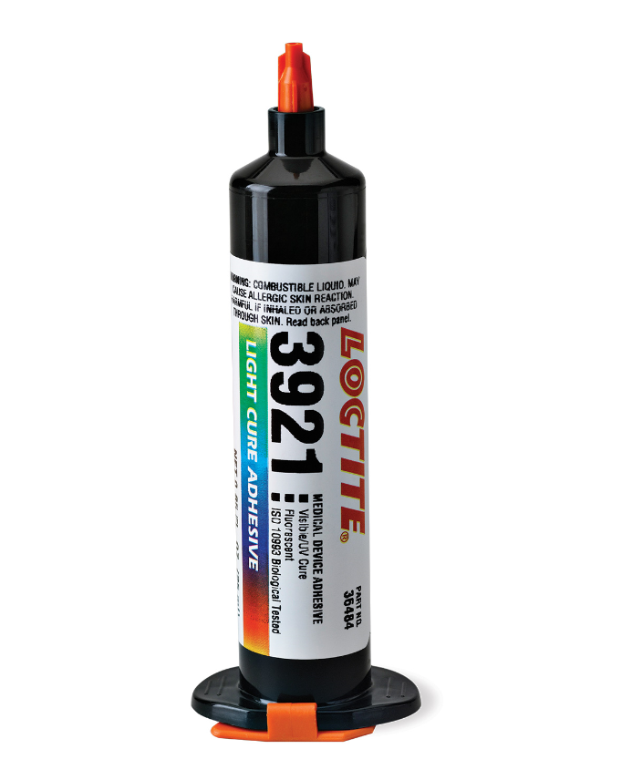
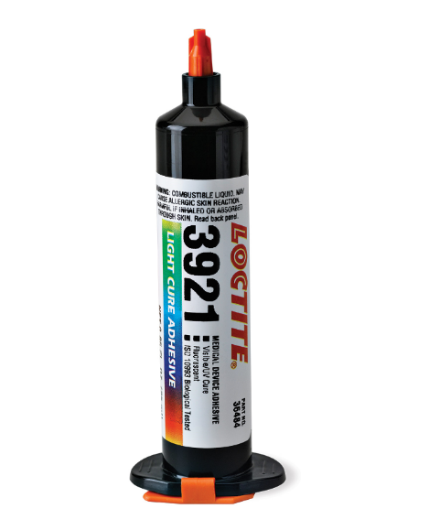

LOCTITE 3921 is a light cure acrylic adhesive that offers faster processing and improved membrane fold protection for spiral wound filtration elements.

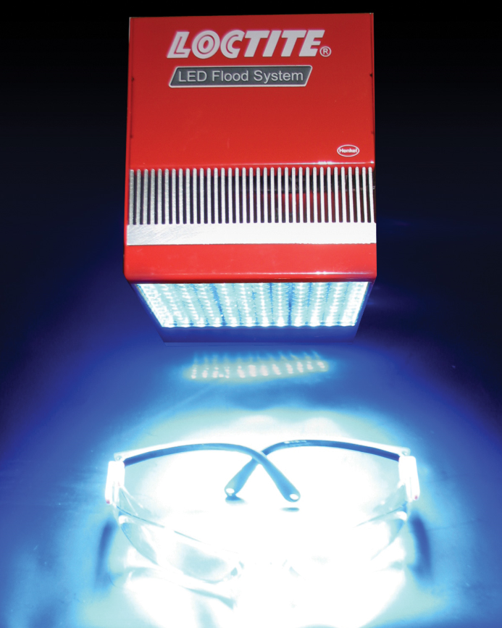

The LOCTITE LED Flood System provides simple, safe and cost effective light curing for LOCTITE 3921.

