September 6, 2018

Performance in international sustainability rankings and indices

Henkel again among global leaders in sustainability

Düsseldorf – International ratings and rankings once more confirm Henkel’s long-standing commitment to sustainability: The company is again listed in the FTSE4Good Index Series. Other sustainability rankings and indices also confirm Henkel’s leading role, among them Oekom Research and French rating agency EcoVadis.

Independent sustainability experts confirm Henkel’s efforts in successfully implementing its sustainability strategy yet again. In September, the company was included in the Ethics Index FTSE4Good. Since its launch in 2001, Henkel has been included in the index introduced by the Financial Times and the London Stock Exchange. Additionally, Henkel is listed in this year’s Euronext Vigeo Eiris Sustainability Indices World 120, Europe 120 and Eurozone 120, as well as in the Ethibel Sustainability Index (ESI), Excellence Europe and the Ethibel Sustainability Index (ESI) Excellence Global. They are issued by transatlantic stock exchange NYSE Euronext and rating agency Vigeo Eiris and include the 120 highest ranking companies in the respective index.

Again industry leader at Oekom
In the Corporate Responsibility Review 2018 by Oekom Research and the updated Oekom Corporate Rating, Henkel received prime status as well as the top grade in the Household & Personal Products category. Oekom research awards companies which are leading in field of sustainability in their respective industries. The assessment of the social and environmental performance of a company is based on more than 100 criteria, reflecting both general aspects as well as criteria selected specifically for each industry.

Repeated Gold rating by EcoVadis
As a member of the “Together for Sustainability” initiative promoting a more sustainable supply chain, Henkel’s sustainability management was again analyzed by international rating agency EcoVadis in 2018. Based on its excellent assessment results, Henkel is among the top 1 percent of the most sustainable companies worldwide – both in the household and personal care category and in comparison to all companies evaluated by EcoVadis.

More information about Henkel’s sustainability efforts and an overview of all rankings can be found here: www.henkel.com/sustainability

About Henkel
Henkel operates globally with a well-balanced and diversified portfolio. The company holds leading positions with its three business units in both industrial and consumer businesses thanks to strong brands, innovations and technologies. Henkel Adhesive Technologies is the global leader in the adhesives market – across all industry segments worldwide. In its Laundry & Home Care and Beauty Care businesses, Henkel holds leading positions in many markets and categories around the world. Founded in 1876, Henkel looks back on more than 140 years of success. In 2017, Henkel reported sales of 20 billion euros and adjusted operating profit of around 3.5 billion euros. Combined sales of the respective top brands of the three business units – Loctite, Schwarzkopf and Persil – amounted to 6.4 billion euros. Henkel employs more than 53,000 people globally – a passionate and highly diverse team, united by a strong company culture, a common purpose to create sustainable value, and shared values. As a recognized leader in sustainability, Henkel holds top positions in many international indices and rankings. Henkel’s preferred shares are listed in the German stock index DAX. For more information, please visit www.henkel.com.

Photo material is available at www.henkel.com/press

Contact Jennifer Ott Hanna Philipps
Phone +49 211 797-27 56 +49 211 797-36 26
Email jennifer.ott@henkel.com hanna.philipps@henkel.com

Henkel AG & Co. KGaA

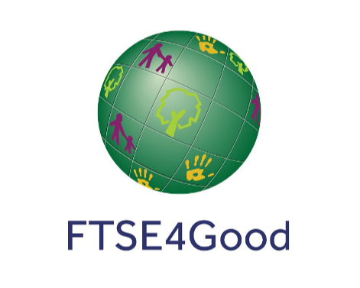
Henkel has been part of the FTSE4Good Ethics Index Series since 2001.

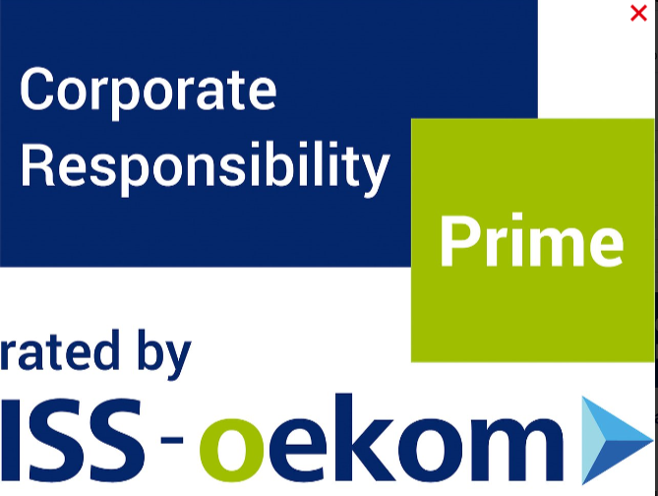
Henkel receives prime status in the Household & Personal Products category from Oekom.

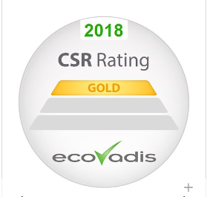
EcoVadis confirms again that Henkel is among the top 1 percent of the most sustainable companies worldwide.

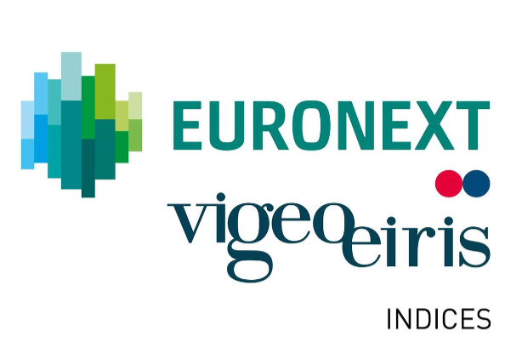
Henkel is again listed in the Euronext Vigeo Eiris Sustainability Indices World 120, Europe 120, and Eurozone 120.

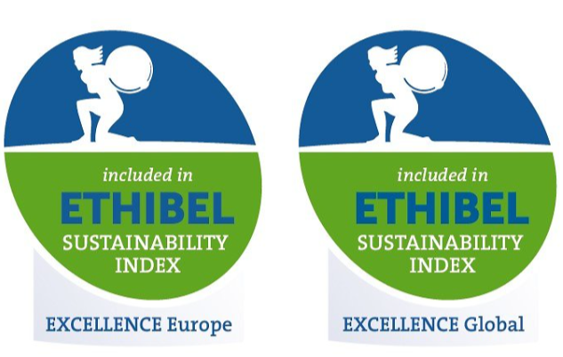
Henkel is again included in the “Ethibel Excellence Europe” and the “Ethibel Excellence Global” sustainability indices.

